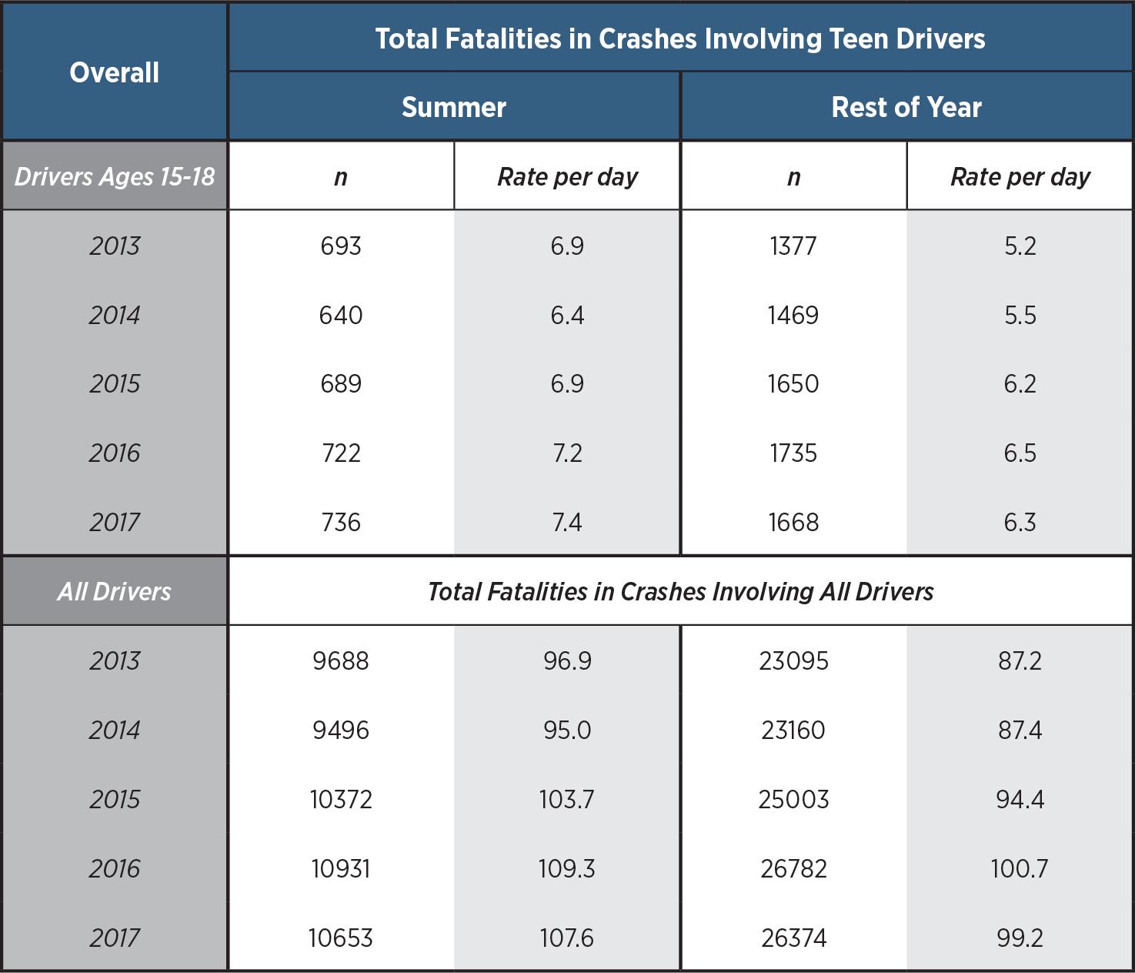

Data from the National Highway Traffic Safety Administration (NHTSA) Fatality Analysis Reporting System (FARS) were used to quantify crash deaths.

